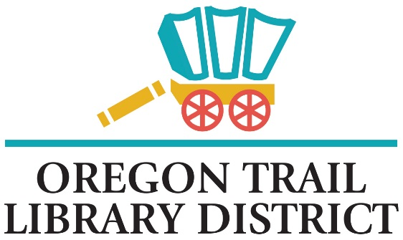
PUBLIC NOTICE

Oregon Trail Library District
Board Meeting
Wednesday April 16, 2025 6:30pm
Irrigon Branch
Zoom: https://us02web.zoom.us/j/89441653628

Call to Order
- Call to Order
- Roll Call

- Consent Agenda (The consent agenda allows the Board to approve all items together without discussion or individual motions. Board members can request an item be removed for later in the meeting and discussion)

- Approve April 2025 financials
- Approve April 2025 minutes

- Public Comment (2 minutes per speaker)

OLD BUSINESS
- Hacker Agreement progress
- Saturday details

NEW BUSINESS
- New Budget Committee date
- Employee wages 2025 2026
- SDAO Training
- Librarian Report

